Task No 01:

Write a program that takes user input and then print backward counting from this input (number) till 0.

Solution:

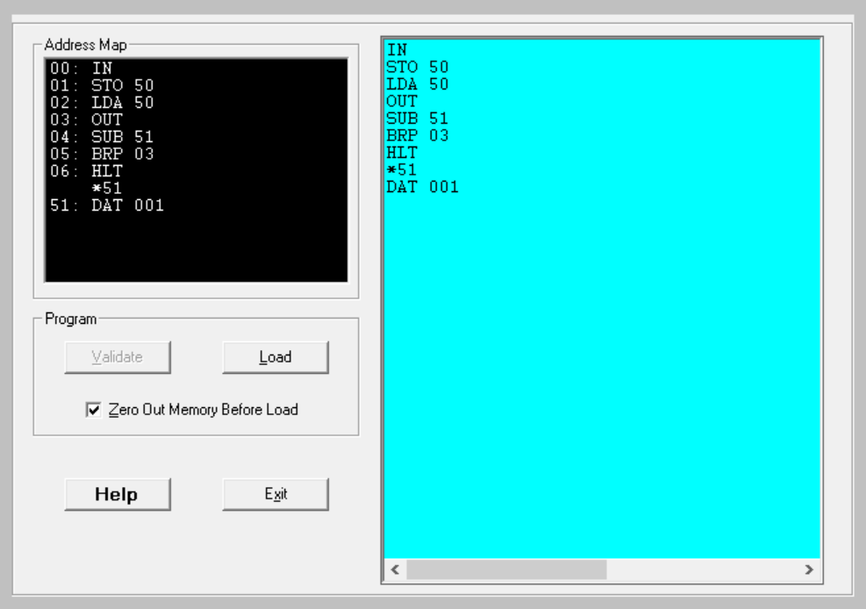

Output:

*Figure 1: Hardware View*

*Figure 2: Trace View*

Task No 02:

Write a program that prints the series of even numbers in the range of 0-10.

Solution:

Output:

*Figure 1: Hardware View*

*Figure 2: Trace View*

Task No 03:

Write a program that takes an input from user and then print the table of it.

Solution:

Output:

*Figure 1: Hardware View*

*Figure 2: Trace View*